Braunton Academy
BRAUNTON ACADEMY

Humanities Department – Extended Learning Project

Year 7: Olympics Project

This document describes how to go about your MILO ‘Olympic’ project. This links all the Humanities subjects of Citizenship, History, Geography and RE.

If you are unsure about your project at any time, please speak to one of the Humanities teachers.
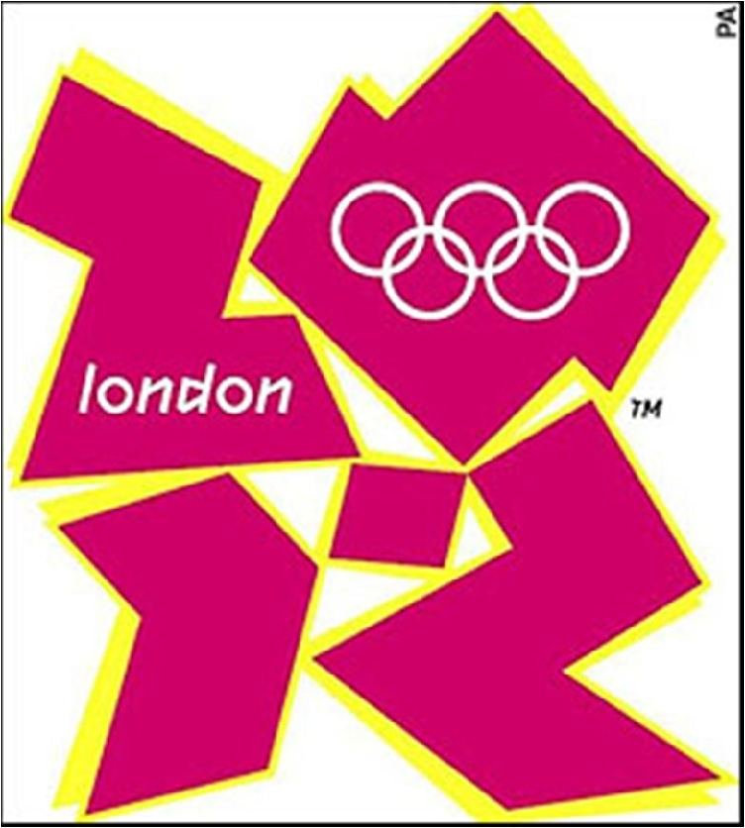

Name: Class:

Date Project Due In:

Assessment criteria:

Level | Description
 | State some reasons why London was chosen to hold the
3 | 2012 Olympics. Identify some effects of the 2012
 | Olympics.
 | Describe why London was chosen to hold the 2012
4 | Olympics and describe some of the possible impacts
 | (effects).
 | Include a detailed history of the games and start to
5 | explain why London was chosen to hold the 2012
 | Olympics. Show that you can give some explanation of
 | the effects of the Olympics.
 | Analyse information in some detail and explain why
6 | London was chosen to hold the 2012 Olympics. Show
 | that you can explain a range of impacts (both good and
 | bad).
 | Analyse information in detail and explain fully why
7 | London was chosen to hold the 2012 Olympics. Show
 | that you can explain a range of good and bad impacts
 | (on people, environments and places).
 | Produce an exceptional project that completes all of the
8 | tasks to an excellent standard with clear evidence of
 | extended research and commitment to producing high
 | quality work.

Your project will take the form of a written piece of work - you may use ICT to help you. We expect all written work to be your own words and not simply copied from the internet - we can tell!

All tasks must be completed.

In July 2005 it was announced that London had been chosen to host the 2012 Olympic Games.

London won the bid, beating competition from other cities around the world, including Paris and Rio de Janeiro.
TASKS:

Task 1: Written/research task

Write a report about the Olympics. Include the following in your work.

- The history and ethos (the values) of the Olympic Games.

- Where has the main Olympic Park and Stadium been built in London? (include a map).
- Why was this part of London chosen? What was like before?
- What effects (good and bad) has the Olympic Games had? How have different groups of people been affected? How has the environment (surroundings) changed? What did it cost to hold the Olympic Games in London? Remember that there were

both good and bad effects and that some people were pleased and others were unhappy about the changes.
- How has religion and beliefs been seen within the games – research about Saudi Arabian athletes at 2012.

…………………………………………………………………………………………………………………………………………......

Task 2: Fact File

Research one of the Olympic sports and produce a fact-file. In your fact-file you could include:

- The rules
- Who represented Great Britain?

- What kit did they wear?

- Was there a world record broken at the London Games? (e.g. fastest time, longest distance?)
- Which venue was used to host this sport?
………………………………………………………………………………………………………………………………………………

Task 3: Creative

Some people were not happy with the London 2012 logo (on the front cover of this booklet). Design your own logo for the London 2012 Olympics. Be creative!

………………………………………………………………………………………………………………………………………………

Websites to help you: http://www.london2012.com/

http://news.bbc.co.uk/cbbcnews/hi/newsid_3990000/newsid_3993300/3993371.stm

