The 2010 World Cup in South Africa brought in $3.7 billion in sales, according to soccer’s governing body, FIFA. | The majority of the tournament’s income in 2010 World Cup came from the sale of television rights, which generated $2.4 billion.
The Brazilian Institute of Tourism forecasts that visitors to the event will spend over $11bn in the country: more than 20 times the earnings of South Africa during the last World Cup. | The tournament attracts 3.6 billion viewers on average from beginning to end of the tournament.
South Africa hosted 62 World Cup matches, and 97 percent of tickets were sold, generating $300 million. | Marketing and sponsorship sales brought in $1.1 billion from the last World Cup
Fifa predicts that it will collect around $4bn for its own coffers from Brazil 2014, with the majority coming from TV rights and around a third from sponsorship and marketing. | The cost of media buying is set to soar too, with Brazil’s Globo TV network due to make $600m from regular ad slots booked by sponsors during its World Cup coverage.
Last week the Brazilian tourist board forced Adidas to stop selling World Cup t-shirts in the US that featured suggestive images of women. Brazil says that it doesn’t want its women portrayed wearing bikinis and dancing to Samba. It gives people the wrong idea. | Adidas, which recently extended its FIFA partnership until 2030, has predicted that sales from its football division will break the €2bn barrier for the first time in 2014 as a result of the World Cup.
“Neymar (famous Brazilian Footballer) demands the best performance from himself in every game he plays, just as Castrol demands the best performance from our oils every time the engine starts,” says AS Ramchander, vice-president of global marketing at Castrol (official sponsor). | Both Coca Cola and McDonalds have been criticized for advertising junk food that if eaten in large qualities, can be the causes of heart disease, obesity and other health issues.
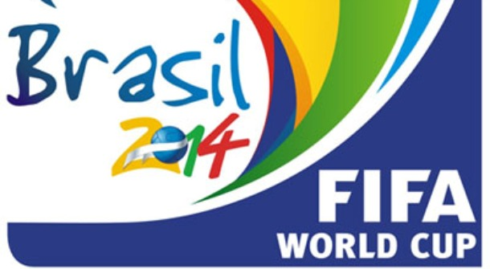
Thought Cards – Football World Cup & Big Business

