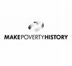
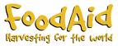
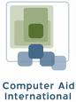

Development projects in LEDCs…
Using the lesson web link here please compose a guide to Aid.
Please ensure you cover the following sections:
- What is aid?
- How do we decide who needs aid?
- How much aid is Africa getting?
- How do governments help?
- What are NGOs and how do they help?
- How do international organisations help?
If you finish the above use the Water Aid website to research the work they do in many LEDCs.

